ALL TEST 6.31 Analysis Results

Performance Summary

Bottom Line
This induction motor is operating normally, no action is required.
X This induction motor exhibits suspicious operation, trending of the induction motor is warranted.
This induction motor exhibits abnormal indications, action is warranted, NOW.

Power Factor Commentary
Power factor exceeds 0.85.
X Power factor is below 0.85, see detailed report.

Current Commentary
X Current variation is within normal limits.
Current variation is beyond normal limits, see detailed report.

Voltage Commentary
X Voltage variation is within normal limits.
Voltage variation is beyond normal limits, see detailed report.
RMS voltage differs from nameplate by more than 5%.

Load Commentary
X Load on the induction motor is consistent with nameplate values.
Load on the induction motor exceeds nameplate values, see detailed report.
Load on the induction motor is less than 25%.

Phase Connection Commentary
X Connections are normal.
Voltage ground reference is NOT neutral.
Loose connection.

Rotor Commentary
Rotor bar health is normal.
X Rotor bar health is questionable, see detailed report.
Load is insufficient to determine rotor bar health, at this time.

Stator Commentary
X Stator health is normal.
Stator mechanical health is questionable. .
Turn to turn short.

Rotor/Stator Air-gap Characteristics
X Dynamic or static eccentricity indications do not exist.
Indications of static eccentricity exist .
Indications of dynamic eccentricity exist.

Harmonic Distortion Commentary
X There is no evidence of harmonic distortion.
There is evidence of harmonic distortion, see detailed report.

Misalignment Indications
X There are no indications of mechanical problems like misalignment or unbalance.
There are indications of mechanical problems like misalignment / unbalance. Perform vibr. survey to identify and correct the cause.

INPUT SUMMARY

NAMEPLATE INFORMATION
 |  | Units
Manufacturer | CHANGZHOU
Serial Number | GMA21021
Tested Equipment | Induction
Power | 20.11 | HP
RPM | 1460.0 | Rpm
Poles | 4
Phases: | 3
Voltage | 380.0 | Volt
Full Load Current | 29.90 | Amp
No Load Current | 3.00 | Amp
Number of rotor bars | 18
Number of stator slots | -1
Torque | 72.3 | Ft.Lb
CT Ratio | 1.000
Service Factor | 115
Motor efficiency | -1.000
Power factor | 0.850

Description:
Belum ada data rotor bar dan stator slot

LEGENDS:
Impedance | = Complex Impedance = vi/ci
CF | = Crest Factor = (waveform peak)/(waveform rms)
VDF | = Transformer Harmonic De-rating Factor = sqrt(2)/CF, %

Slip % | = SRSS sum of slip and harmonic "levels" divided by RMS level of RMS DEMOD spectra between 0 and 65 Hz.
Upper sb | = dB level of upper slip sideband of power line peak
Lower sb | = dB level of lower slip sideband of power line peak
Se, fund | = Location of pole pass frequency fundamental, Hz
Se, harm | = Number of pole pass frequency harmonics
Rotor bar health | = Estimate of the percent of broken or cracked rotor bars
RB Hlt Index | = Rotor bar health index

THDF | = Voltage De-rating Factor = 100 - (voltage unbalance, %)^2, %
Level | = Sum of spectral amplitudes of pole pass frequency fundamentals and harmonics
Thd | = Total harmonic distortion
+Ve | = Positive sequence harmonic
-Ve | = Negative sequence harmonic
Zero | = Zero sequence harmonic

Detailed Calculations

Running Speed = 24.872 Hz [1492 RPM]

Pole pass frequency = 0.580 Hz [35 RPM]

Load = 27.9 %
Time
 | RMS | Peak | CF
Current 1 | 15.580 | 34.390 | 2.207
Current 2 | 15.980 | 26.197 | 1.639
Current 3 | 15.830 | 26.349 | 1.664
Average | 15.797 | 28.979 | 1.837
% dev | 1.4 | 18.7 | 20.2

THDF = 77.0

Time
 | RMS | Peak | CF
Voltage 1 | 386.700 | 548.670 | 1.419
Voltage 2 | 387.200 | 546.020 | 1.410
Voltage 3 | 386.500 | 538.020 | 1.392
Average | 386.800 | 544.240 | 1.407
% dev | 0.1 | 1.1 | 1.1

VDF = 100.0

 |  |  | App. Power | Real Power | Reac. Power
 | Power factor | Impedance | kVA | kW | kVARS
Phase 1 | 0.440 | 24.820 | 3.479 | 1.531 | 3.124
Phase 2 | 0.440 | 24.230 | 3.572 | 1.599 | 3.194
Phase 3 | 0.440 | 24.416 | 3.530 | 1.511 | 3.190
Avg/Total | 0.440 | 24.489 | 10.581 | 4.641 | 9.508
% dev | 0.0 | 1.4

Demand Pwr = 6.22 HP

Load:27.9 %

Motor Eff.:84.6 %

Loss due to THD:

Loss due to Imp.Unb.:1.35 %

PF variance:2.10%

Output Pow.:3.83 KW

Output Trq.:18.08 Ft.Lb

Summary of Rotor Bar Health |  |  |  |  | Power line dB diff. |  | RB Hlt Index
 | Se, fund |  | Se, harm | Level % | Upper SB | Lower SB | RB Hlt Index
Measured | 0.580 |  | 1 | - | -23.011 | -22.620 | 14.798
Severity level |  | Rotor Condition Assessment |  |  | Recommended Corrective Action
7 |  | Multiple broken rotor bars and end rings very likely. Severe problems throughout |  |  | Overhaul or replace ASAP

Harmonic Distortion Results:
Voltage input, from 50.049 Hz harmonics
 | THD Odd % | THD Even % | +ve% | -ve % | Zero % | THD All %
Current 1 | 3.380 | 0.338 | 1.030 | 3.224 | 0.291 | 3.397
Current 2 | *** | *** | *** | *** | *** | 0.000
Current 3 | *** | *** | *** | *** | *** | 0.000
Voltage 1 | 1.456 | 0.083 | 0.622 | 1.314 | 0.117 | 1.458
Voltage 2 | *** | *** | *** | *** | *** | 0.000
Voltage 3 | *** | *** | *** | *** | *** | 0.000

Harmonic distortion table – Peak values, voltage is phase to ground
Hz | Cur1 | Vlt1 | Cur2 | Vlt2 | Cur3 | Vlt3
3000 | 29.3 | 311 | 0.0 | 311 | 0.0 | 311
6000 | 0.1 | 0 | 0.0 | 0 | 0.0 | 0
9000 | 0.1 | 0 | 0.0 | 0 | 0.0 | 0
12000 | 0.0 | 0 | 0.0 | 0 | 0.0 | 0
15000 | 1.0 | 4 | 0.0 | 4 | 0.0 | 4
18000 | 0.0 | 0 | 0.0 | 0 | 0.0 | 0
21000 | 0.3 | 1 | 0.0 | 1 | 0.0 | 1
24000 | 0.0 | 0 | 0.0 | 0 | 0.0 | 0
27000 | 0.0 | 0 | 0.0 | 0 | 0.0 | 0
30000 | 0.0 | 0 | 0.0 | 0 | 0.0 | 0
33000 | 0.2 | 1 | 0.0 | 1 | 0.0 | 1
36000 | 0.0 | 0 | 0.0 | 0 | 0.0 | 0

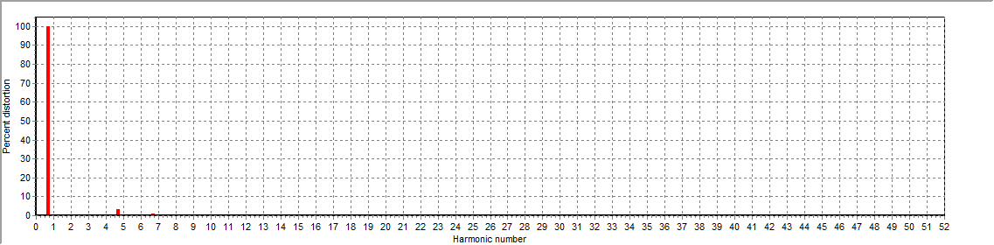
Figure 1: Current harmonic distortion plot

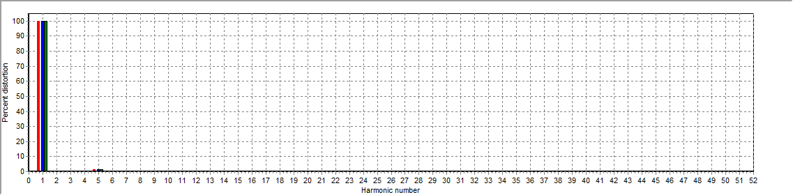
Figure 2: Voltage harmonic distortion plot

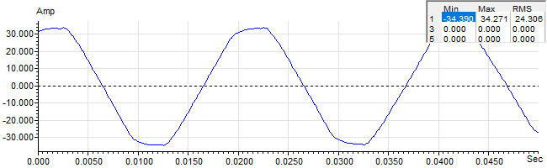
Figure 3: Raw Current

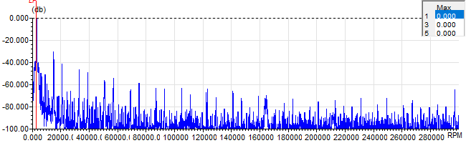
Figure 4: Raw Current Frequency spectrum

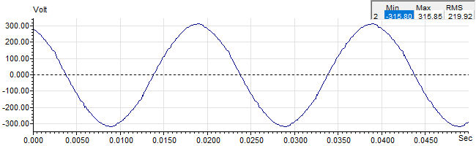
Figure 5: Raw Voltage

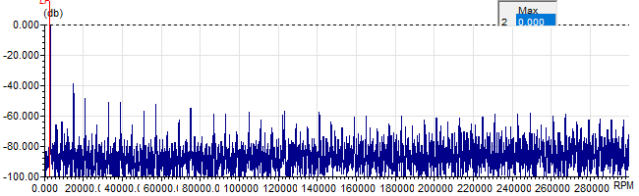
Figure 6: Raw Voltage Frequency spectrum

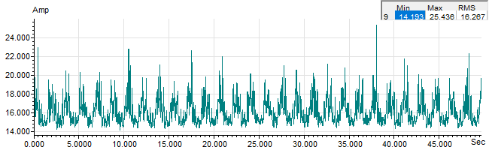
Figure 7: Demodulated current trace

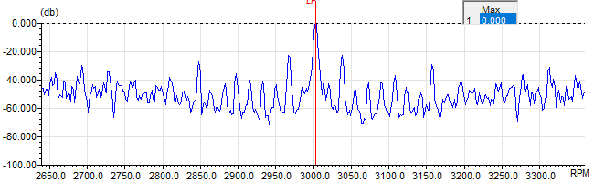
Figure 8: Raw current spectrum

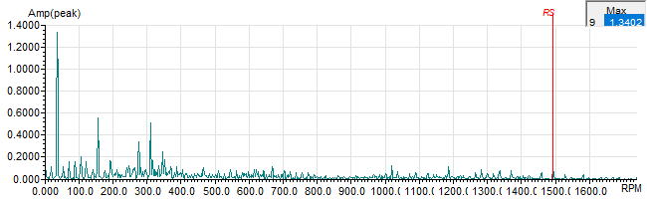
Figure 9: Demodulated current spectrum

